*TABLE CREATION:--

--> CREATE TABLE HZL_Table ("DATE" DATE ,BU VARCHAR2(10),Value NUMBER);

INSERT INTO HZL_Table ("DATE", BU, Value) VALUES (TO_DATE('2024-01-01', 'YYYY-MM-DD'), 'hzl', 3456);

INSERT INTO HZL_Table ("DATE", BU, Value) VALUES (TO_DATE('2024-02-01', 'YYYY-MM-DD'), 'hzl', NULL);

INSERT INTO HZL_Table ("DATE", BU, Value) VALUES (TO_DATE('2024-03-01', 'YYYY-MM-DD'), 'hzl', NULL);

INSERT INTO HZL_Table ("DATE", BU, Value) VALUES (TO_DATE('2024-04-01', 'YYYY-MM-DD'), 'hzl', NULL);

INSERT INTO HZL_Table ("DATE", BU, Value) VALUES (TO_DATE('2024-01-01', 'YYYY-MM-DD'), 'SC', 32456);

INSERT INTO HZL_Table ("DATE", BU, Value) VALUES (TO_DATE('2024-02-01', 'YYYY-MM-DD'), 'SC', NULL);

INSERT INTO HZL_Table ("DATE", BU, Value) VALUES (TO_DATE('2024-03-01', 'YYYY-MM-DD'), 'SC', NULL);

INSERT INTO HZL_Table ("DATE", BU, Value) VALUES (TO_DATE('2024-04-01', 'YYYY-MM-DD'), 'SC', NULL);

INSERT INTO HZL_Table ("DATE", BU, Value) VALUES (TO_DATE('2024-05-01', 'YYYY-MM-DD'), 'SC', 345);

INSERT INTO HZL_Table ("DATE", BU, Value) VALUES (TO_DATE('2024-06-01', 'YYYY-MM-DD'), 'SC', NULL);

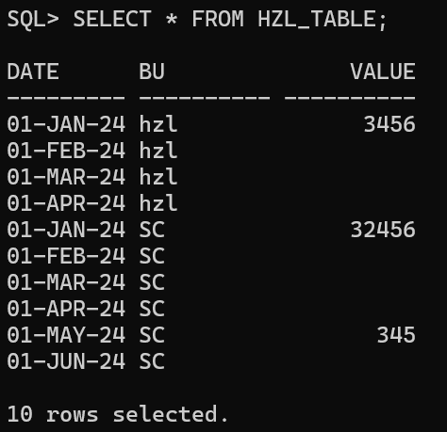

*QUERY FOR DESIRED OUTPUT:--

SELECT "DATE", BU,LAST_VALUE(Value IGNORE NULLS) OVER (PARTITION BY BU ORDER BY "DATE") AS Value

FROM HZL_Table

ORDER BY "DATE", BU;

